Use Cases & Scenarios
The use cases and scenarios are two different techniques, but, usually they are used together.
Use cases identify interactions between the system and it’s users or even other external systems (using graphical notations), while a scenario is a textual description of one or more of these interactions.

Advantages of a Use Case
If you are designing a software or a process then it is necessary to develop a good use case for everything that can happen. Use cases aren’t restricted to processes or software; they are an effective tool for any type of management. The biggest advantage of a Use Case is that it acts as a blueprint for the whole process. Once you write down a use case, anyone who comes in after you will be able to easily fix any issues that are occurring. Instead of spending time first understanding the system, they’ll be able to read the use case and directly begin checking what went wrong.
The more detailed a use case is, the easier it is to understand. Ensure that the summary of the use case defines the context of the use case properly.

Use case involves some symbols to describe the system
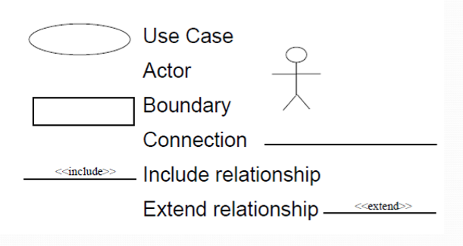

- Actors: Are those who interact with the system; human or other systems
- Interaction (Use Case): It denotes the name of the interaction (verb). It’s represented as a named ellipse.
- Connection: Lines that links between the actors and the interactions.
- Include Relationship: It denotes a connection between two interactions when an interaction is invoked by another. As an example, splitting a large interaction into several interactions.
- Exclude Relationship: It denotes a connection between two interactions when you want to extend an interaction by adding an optional behavior, but you can use the main interaction on its own without the extending interaction.
Now, we are going to use scenarios to describe the interactions in each use case textually. They should have a format and include the following:

- A description of the initial situation.
- A description of the flow of the events or interactions with the system
- A description of the exceptions, or in other words, what can go wrong, and how it can be handled.
- Any concurrent activities should be mentioned
- A description of the final state.
Use case and scenarios are effective techniques for eliciting the requirements. But, because they focus on the interactions with the system, they aren’t effective for eliciting high-level business, non-functional, or domain requirements.

Use case #1
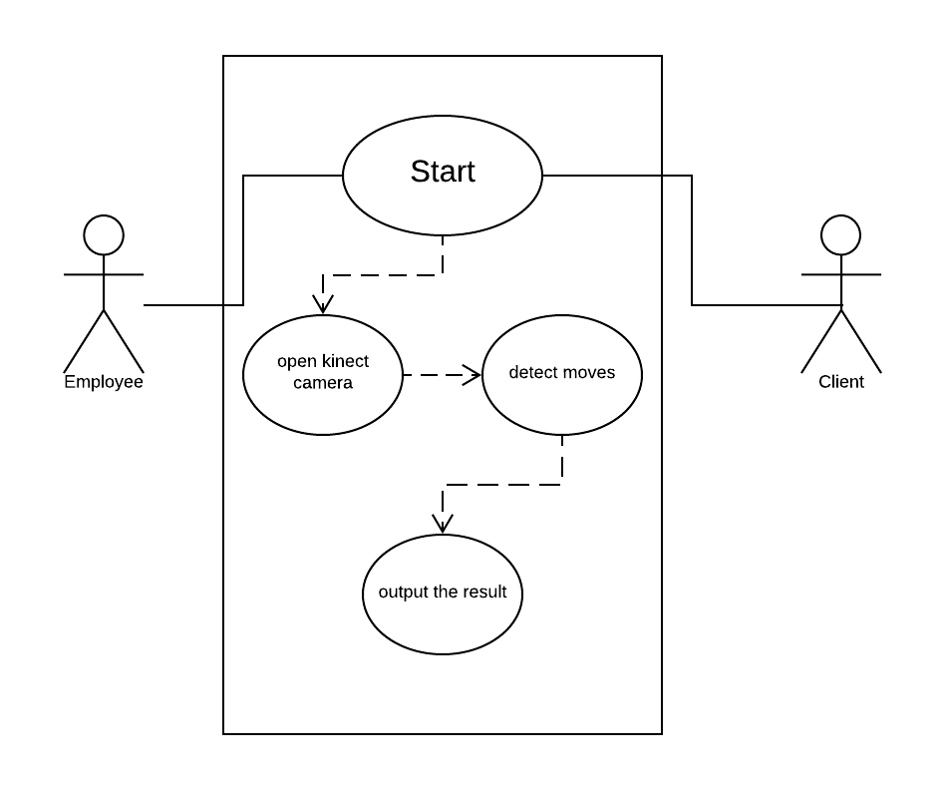

Title: | Move Detection
Description: | It shows how an employee can start the application, make it ready to detect moves of the client and shows the result of the move in text and audio.
Actors: | Employee of an organization and its client.
Pre-conditions: | The system is off
Post-conditions: | Detect and extract the move that just happened and output the result
Main  Success Scenario: | - The employee opens the application.  - He’ll press “start” button on home page  - The client begins to do his moves.  - Kinect detects every single move.  - System analysis each move.  - The output is shown on screen as a real-time result.  - Convert the text “result” into audible voice.
Exceptions: | There is no actions can disrupt the process to be done.
Frequency of Use: | high
Priority: | high

Use case #2

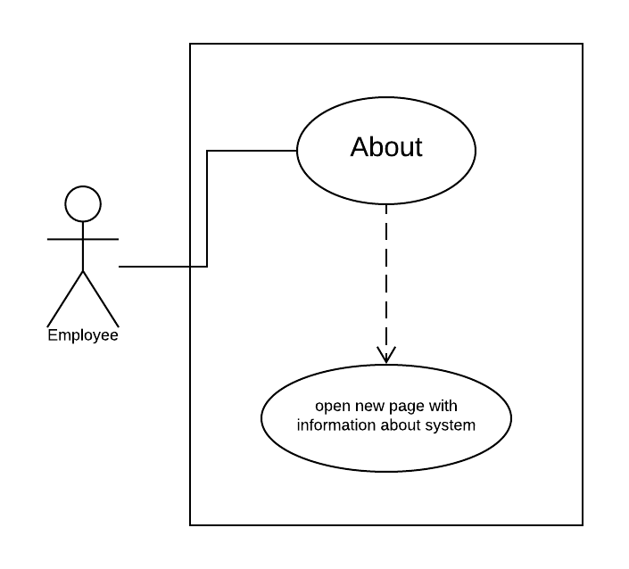

Title: | Knowing about system.
Description: | It shows to user some information about the application.
Actors: | Normal users of system.
Pre-conditions: | The application is on home page.
Post-conditions: | Some information about the application is shown.
Main  Success Scenario: | - The user will press “about” button on home page.  - System opens a new tab with all information available about it.
Exceptions: | There is no actions can disrupt the process to be done.
Frequency of Use: | low
Priority: | Medium

Use case #3

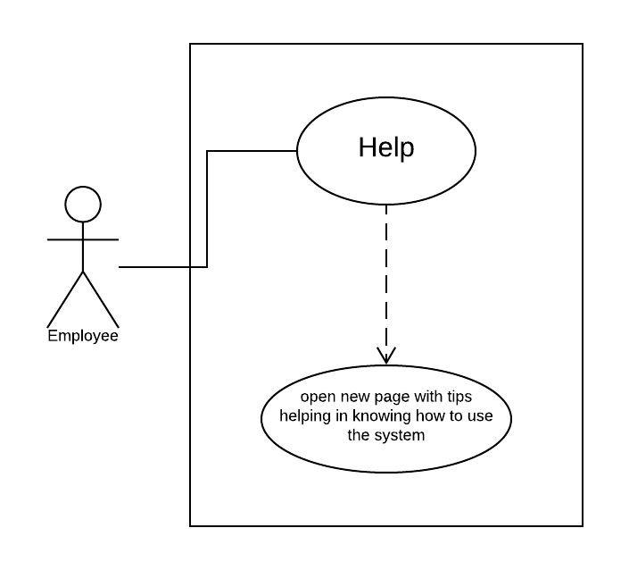

Title: | Help
Description: | It shows some tips to help users to know how to use the application.
Actors: | Employees of the organization.
Pre-conditions: | The application is on home page.
Post-conditions: | Tips helping in knowing how to use system.
Main  Success Scenario: | - The user will press “help” button on home page.  - System opens a new tab with all tips available to explain how to use it.
Exceptions: | There is no actions can disrupt the process to be done.
Frequency of Use: | Medium
Priority: | Medium

Use case #4

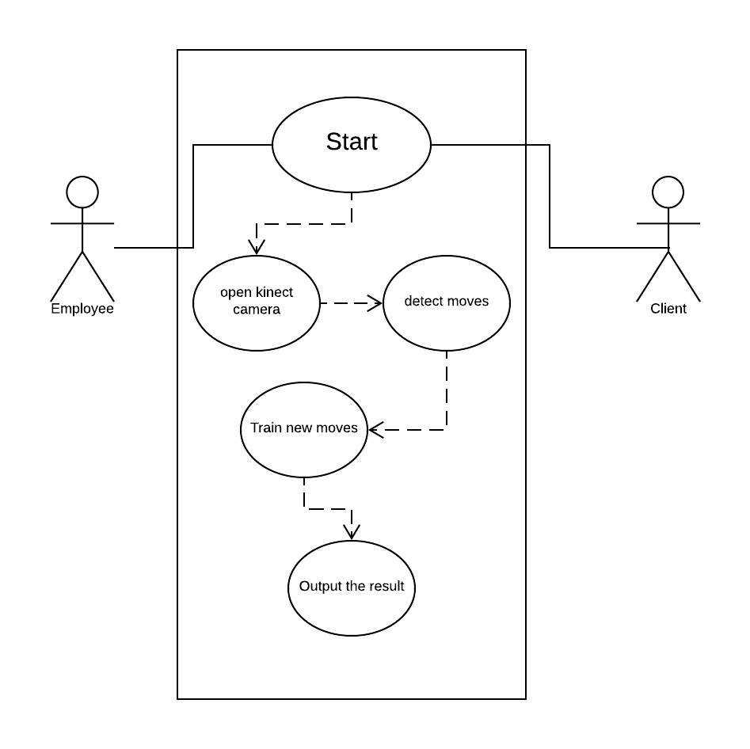
Title: | Training of moves
Description: | It helps the user to train new moves and get the result on output screen.
Actors: | Employee and client of an organization.
Pre-conditions: | The system detects a move and can’t analyze it.
Post-conditions: | Get the result of new move on output screen.
Main  Success Scenario: | - The employee opens the application.  - He’ll press “start” button on home page  - The client begins to do his moves.  - Kinect detects every single move.  - System analysis each move and can’t find it.  - The system trains the new move.  - “test” button takes the result and put in on output page.  - Convert the text “result” into audible voice.
Exceptions: | The system may fail in detection of the move. It will show an error message to repeat the move again.
Frequency of Use: | high
Priority: | high

